BOOKENDS HOSPITALITY PVT. LTD.
Internal Operations — Regulatory Readiness Series

FSSAI Schedule 4 & FDCA Compliance Readiness Report

Central Hot Kitchen — Surat, Gujarat

Outlet / Brand | Central Hot Kitchen
Location | Surat, Gujarat
Business Category (presumed) | BOOKENDS HOSPITALITY PVT. LTD.
Inspection / Audit By | Vishal Patel
Report Prepared By | Nikil Malviya

Ref | Priority | What the evidence shows
S1 ★ | Critical | Not available
K19 ★ | Critical | A pest (cockroach) was photographed on the floor on the audit day, despite this checkpoint being scored 2. The pest-control certificate on file is addressed to a different business name and had already lapsed for over a  year.
K15 ★ | 1 evidence | Fitness certificates not available.

Ref | Checkpoint | Rating | Priority | Remark
S1 ★ | FSSAI licence displayed and valid; Food Safety Display Board put up | 0 | Major | Not available

S10 | Drinking water potable/filtered; dispenser and jug clean | 2 | Compliant | —
S13 | Restrooms clean and stocked; doors do not open directly into food area | 2 | Compliant | —
K18 | Hand wash stations stocked — soap, sanitizer, paper towel | 2 | Compliant | —
K20 | Drain traps in place, flowing and clean; no standing water | 2 | Compliant

Ref | Checkpoint | Rating | Priority | Remark
K1 ★ | No expired or undated items anywhere on the premises | 0 | 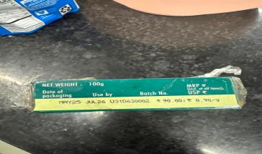  Major | 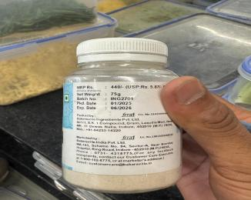  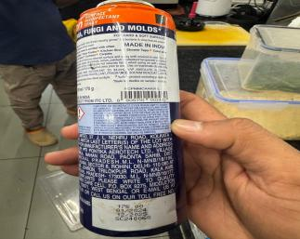  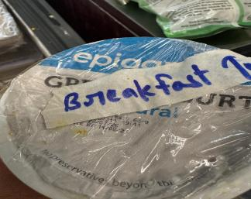  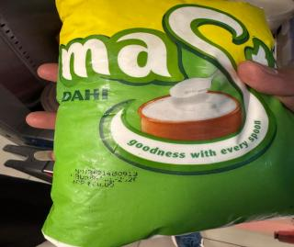
Ref | Checkpoint | Rating | Priority | Remark
K2 | Decanted containers labelled with name and date; FIFO followed | 0 | Major | 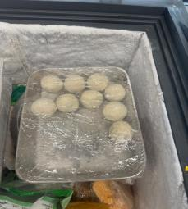  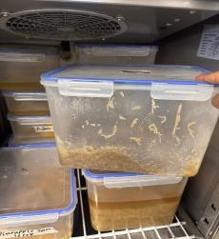  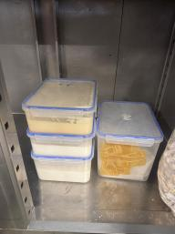
K4 ★ | Raw and cooked food completely segregated | 2 | Compliant | —
K5 ★ | Veg segregated in storage and prep | 2 | Compliant | —
K6 ★ | Chiller ≤ 5°C, freezer − 18°C; temperature log up to date | 0 | Major | 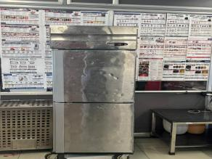  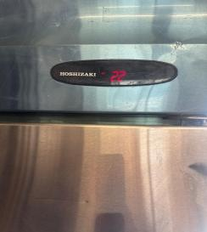
K7 | Hot holding ≥ 60°C; cooking to a core temperature ≥ 75°C | 2 | Compliant | —
K8 | Thawing only under refrigeration — never at room temperature | 2 | Compliant | —
K14 | Only approved colours/additives used; declaration on file | 2 | Compliant
K19  ★ | No pest activity; pest-control service record up to date; stations mapped | 0 | Major | No record

Ref | Checkpoint | Rating | Priority | Remark
S12 | Waste bin covered, foot-operated, not overflowing | 0 | Major | 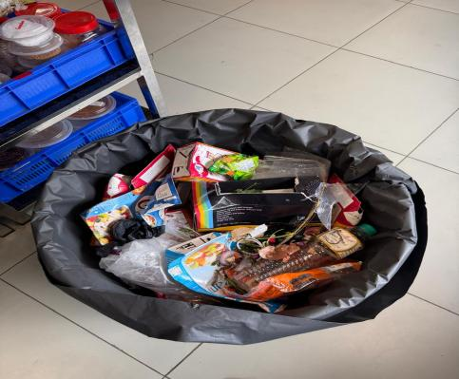
K9 | Chemicals labelled not mention and stored away from food | 2 | Compliant
K21 | Waste segregated, bins covered, emptied daily | 0 | Major | 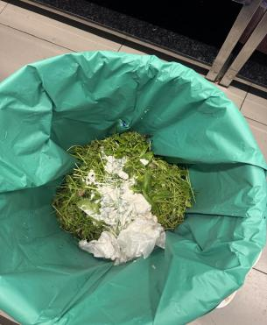
S4 | Floors, walls, ceiling clean — no cobwebs, seepage or flaking paint | 0 | Major | 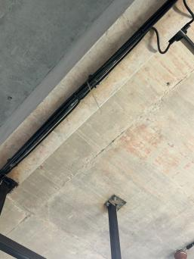
K22 | Exhaust and hoods degreased; ventilation adequate; lights protected | 2 | Compliant | —
K3 | Storage 15 cm off the floor; no cartons or food on the floor. | 2 | Compliant | —
K11 | Colour-coded boards / separate prep tools in use | 2 | Compliant | —
K12 | Frying oil within TPC limit; oil-change log up to date | 2 | Compliant

S7 | No unwell staff on duty; cuts/wounds covered with waterproof dressing | 2 | Compliant
K15 ★ | Medical fitness certificate up to date for every food handler | 0 | Major | Not available
K17 | Kitchen staff — cap, apron, trimmed nails, no jewellery; no smoking or paan | 0 | Major | 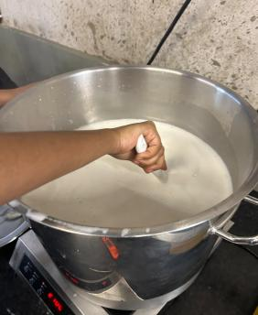  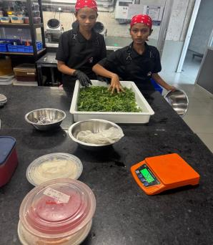
K16 | FoSTaC-certified supervisor on roster; certificate available | 0 | Major | Not available
K23 ★ | Water potability report valid  — tested within the last 6 months | 0 | Major | Team reports an informal daily check is done, but there is no documented report; the formal 6-monthly lab report has not been renewed.  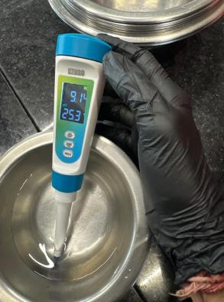  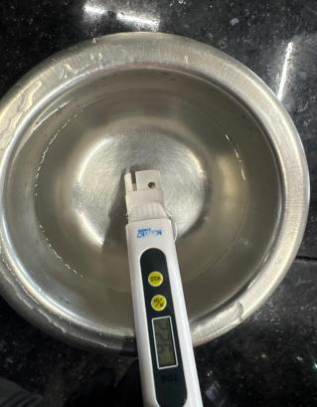
K24 | Deep-cleaning schedule up to date and followed; dispense log with temperature (CK checklist) | 0 | Major | 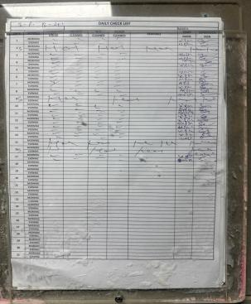

K13 | Food-contact surfaces and equipment clean — no rust, damage or wooden patches | 2 | Compliant | —
K10 | Dry store clean, ventilated, pest-free. | 0 | Major | 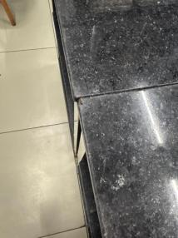

Score & Grade
Section | Available marks | Obtained marks | %
A — Kitchen Area | 76 | 36 | 47.4%
Total (Overall) | 76 | 36 | 47.4%

Conclusion
- Overall standing — 36/76 (47.4%) for the kitchen area — the Non-Compliance band, below the 50% floor. 6 of the 8 ★ criticals are Non-Compliant (S1, K1, K6, K15, K19, K23); only K4 and K5 pass.
- Cold chain is the priority — K6 ★ fails: chiller/freezer temperatures and the temperature log are Non-Compliant, alongside expired or undated stock (K1 ★) and unlabelled decanted containers (K2). These are live food-safety failures rather than paperwork gaps, and as a central kitchen anything leaving here carries that risk to every outlet it supplies.
- No statutory documents to produce — S1 ★ is recorded as “Not available” rather than merely undisplayed, and K15 ★ (medical fitness), K16 (FoSTaC) and K23 ★ (water potability) are likewise unavailable — so an FDCA visit today would find no licence, health records, trained-supervisor certificate or water report on site.

